R&D PROJECT EXPERIMENT AND TEST REPORT
DATE OF TEST:
August 2025
R&D PROJECT:
LithoSpace – Extraterrestrial Geochemistry Data Platform
EXPERIMENT/TEST NO: 001
R&D CORE ACTIVITY:
Lunar Dataset Ingestion and Normalisation Engine
HYPOTHESIS ASPECT TESTED:
That the ingestion engine developed during the 2023–24 R&D cycle for Apollo 11 can be successfully expanded to handle all Apollo missions (11–17), with improved handling of sample metadata, format inconsistencies, and geospatial tagging.

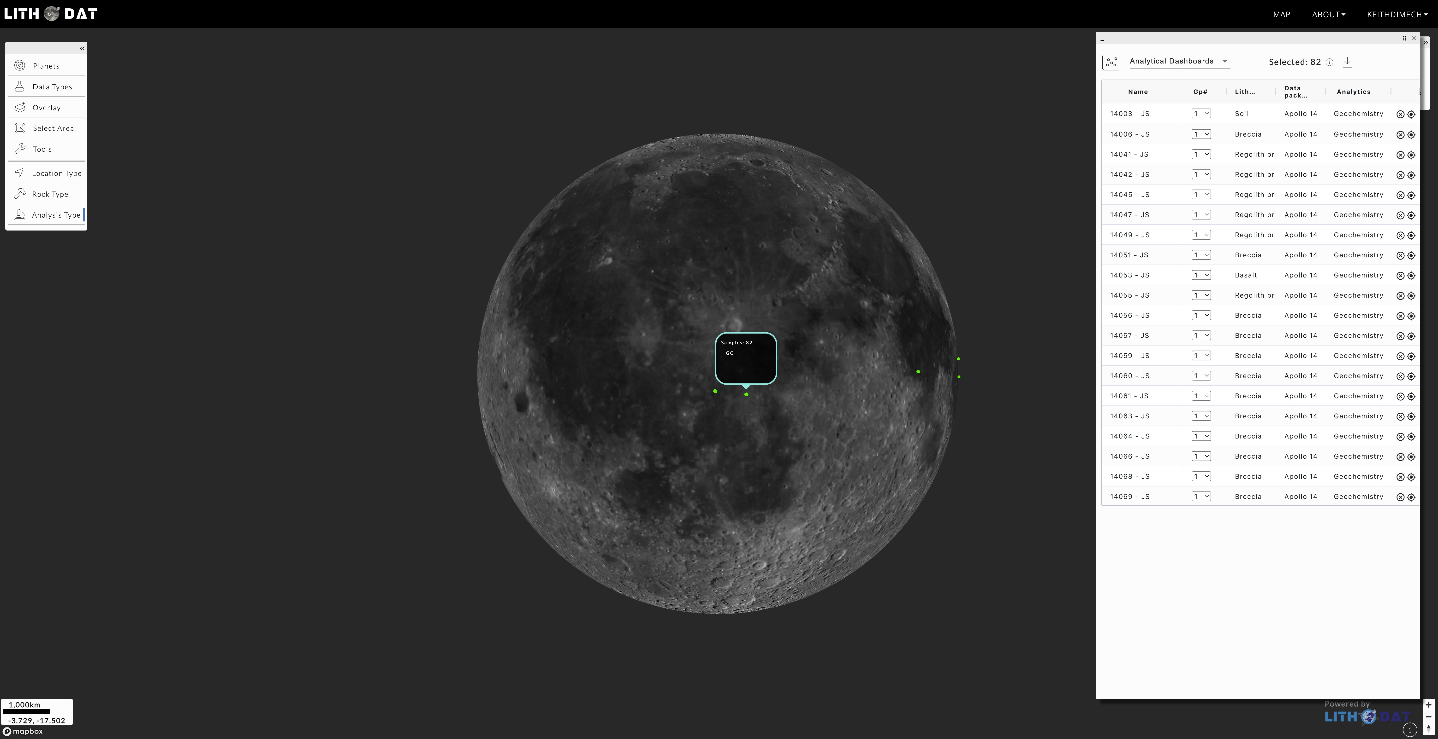
DESCRIBE HOW EXPERIMENT/TEST UNDERTAKEN:
In 2023–24, the ingestion engine was validated for Apollo 11 using RMarkdown scripts to clean and import geochemical data into LithoSpace. This year, the pipeline was extended to Apollo 12–17 using additional datasets from the Lunar Sourcebook and PDS archives.
Challenges included inconsistent formatting (elemental vs oxide units), missing coordinates, and variation in sample metadata. Updates were made to the Excel wizard schema and ingestion logic to support batch processing of all lunar datasets. A crosswalk table was created to match mission-specific naming conventions. All files were harmonized to show lithologies, geochemistry and rock type and geotagged using Analyst’s Notebook and USGS archives.
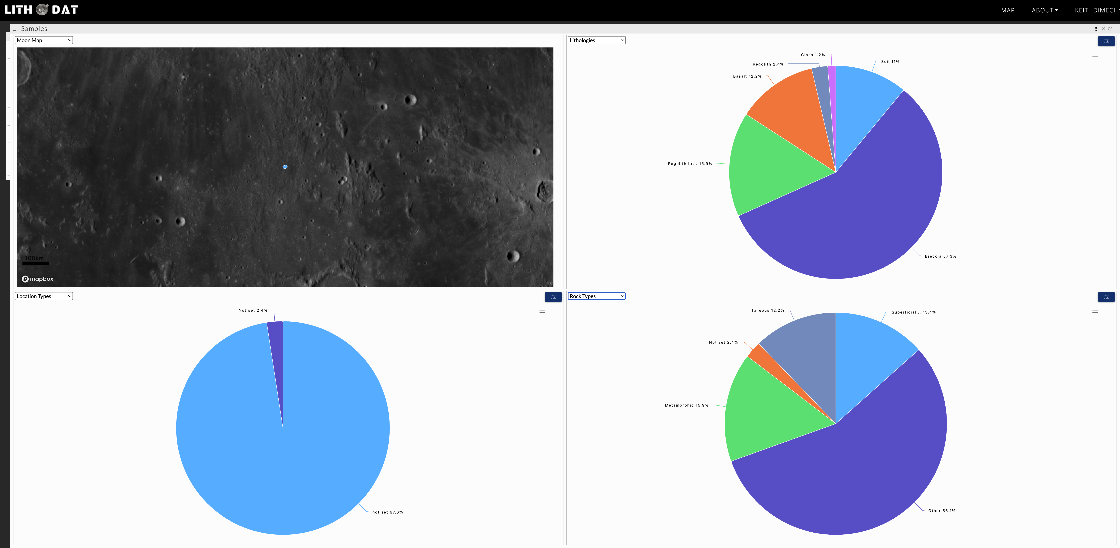
TEST EVALUATION CRITERIA:
1. Successful ingestion of all Apollo missions into the updated pipeline.
2. Conversion accuracy of location to position on map
3. Metadata completeness (sample type, mission, coordinates).
4. QA/QC logs
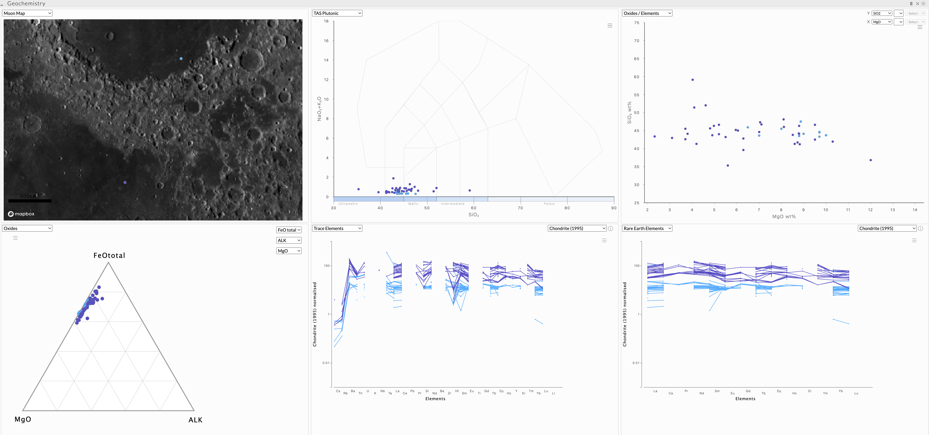
TEST RESULTS:
1. Apollo missions (11, 12, 14) and Luna missions (16, 20, 24) successfully ingested.
2. Harmonised values show <1% deviation from reference values.
3. Results showing trace elements, REE and oxides effectively through Lithospace
5. Visual comparison confirmed accurate geolocation and chemistry display.
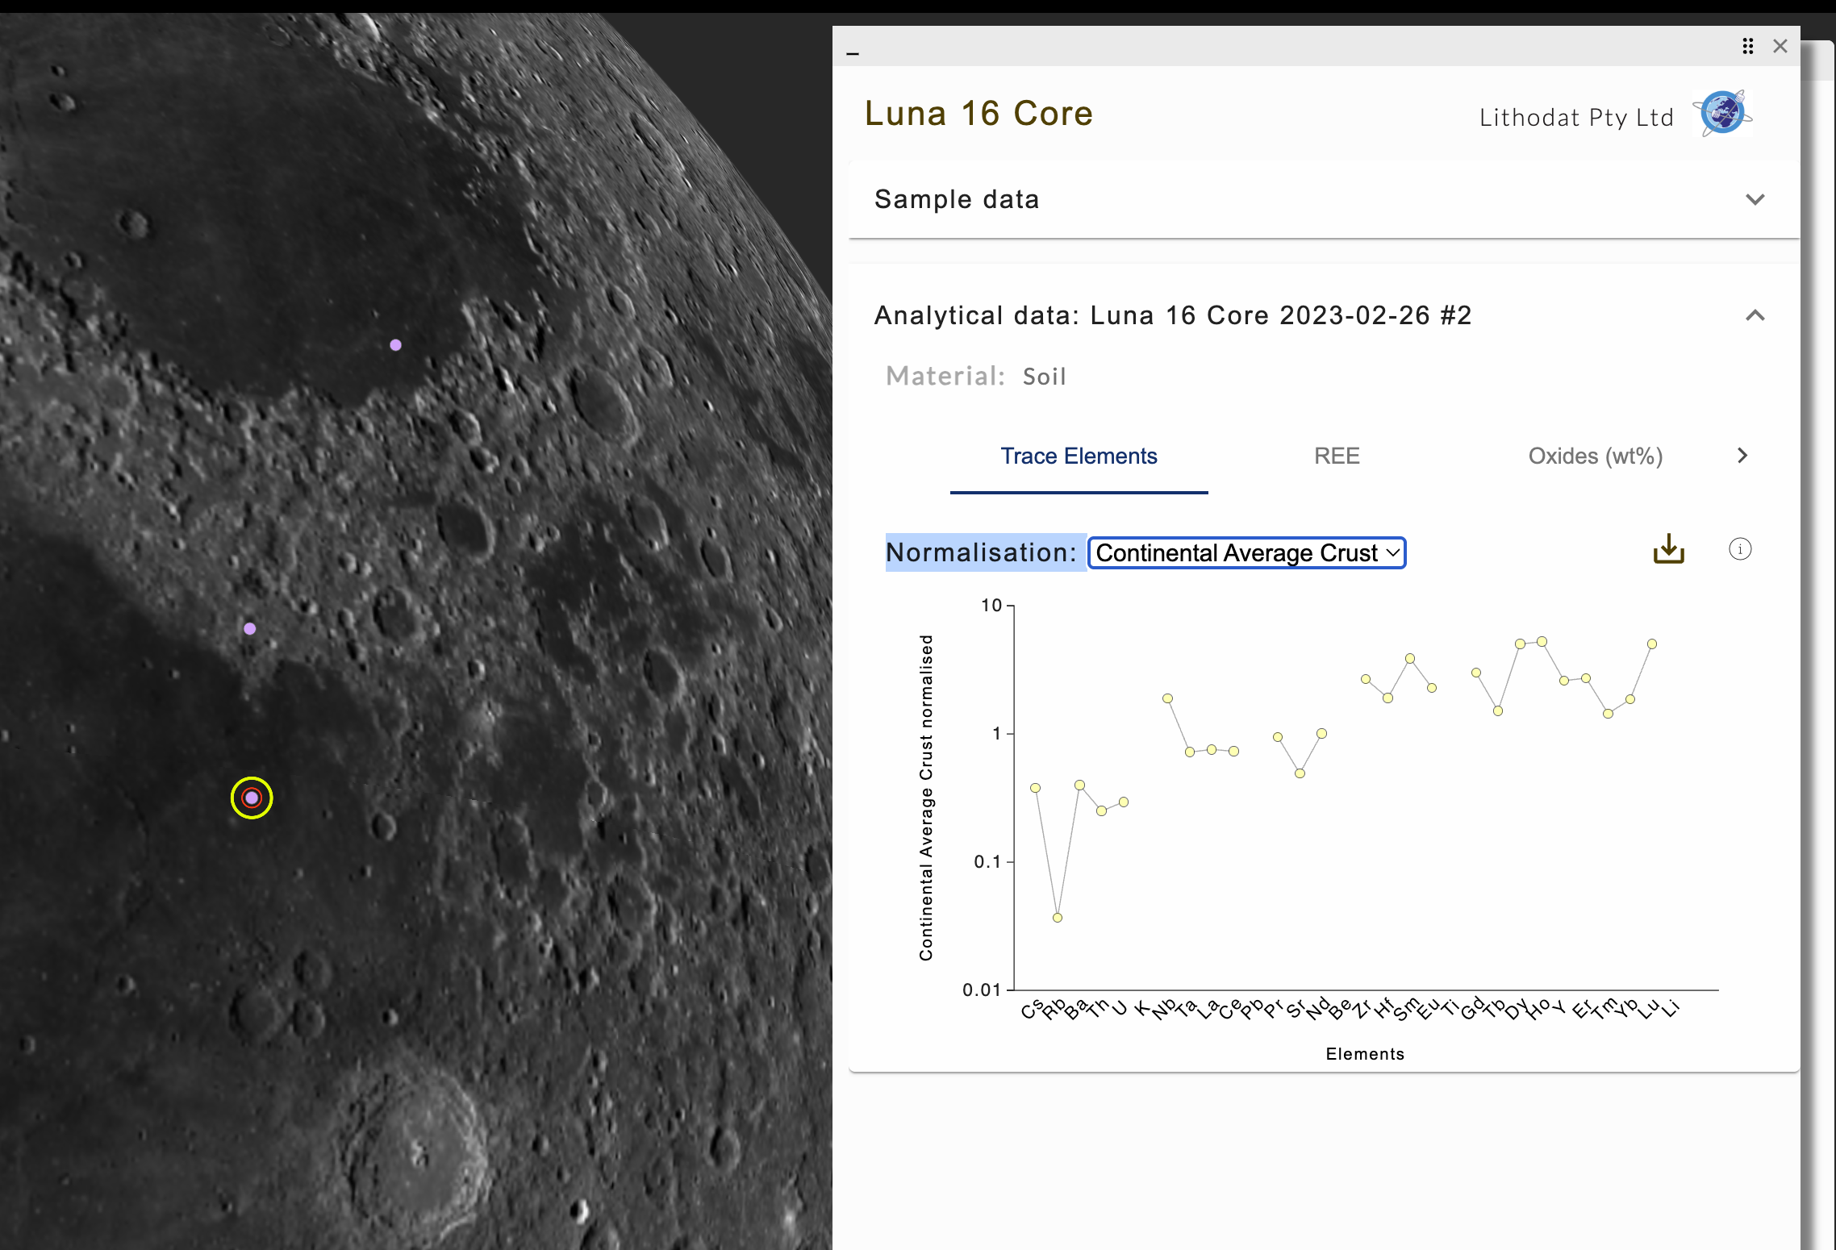
TESTING CONCLUSIONS:
1. The ingestion pipeline has matured from a single-mission prototype to a full suite tool.
2. Harmonisation logic, unit conversions, and metadata tagging are production-ready.
3. Remaining edge cases suggest further refinement in lunar rover datasets (Luna, Chang’e).
4. Apollo ingestion schema to serve as baseline for Mars ingestion and cross-mission comparisons.
EVIDENCE COLLECTED:
- Apollo 11 and Luna missions raw and cleaned data
- Underlying reports QAQC and data available via the lithospace platform
- Dashboard screenshots
- QA logs and ingestion reports
- PDS and USGS source citations

